# Install e1071 package

## Start RStudio

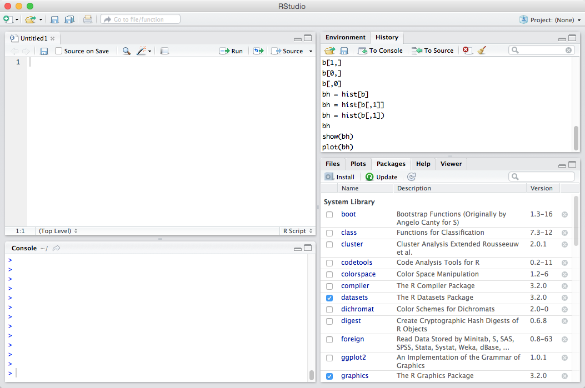

## Download and Install e1071 Package

I

n the console window enter

* install.packages(“e1071”)

In the figure below you will see the typed command and the output in the console window on the left. If you select the “Packages” tab on the bottom right you should now see that the e1071 package has been installed.

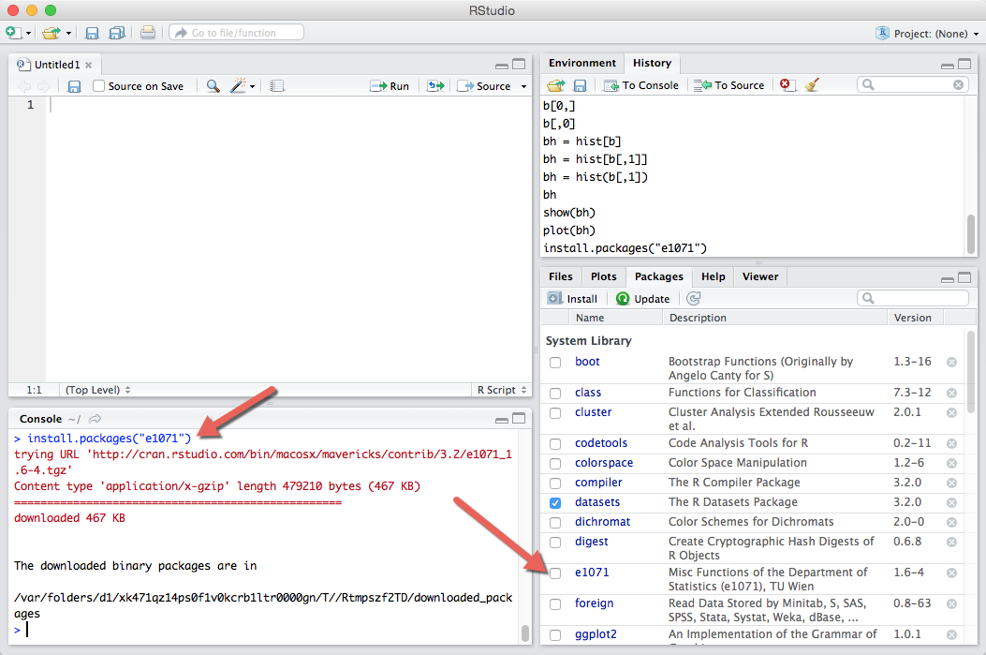

## Load the e1071 library so it is accessible to R

In the console window enter

* library(“e1071”)

To list the documentation associated with Support Vector Machines in the console window enter

* $svm

The red arrows below point to where these commands have been entered.

